# Additional Information Form

## Question 1 Reasons for choosing your program and Waterloo (*Required)

Please tell us about your educational goals, your interest in your chosen program(s), and your reasons for applying to the University of Waterloo. If you have applied to more than one program please discuss your interest in each program. (900 character limit)

Innovation generates ideas that advance our society. Waterloo competitors in Hack The North explained to me how the co-op programs grew their innovation, which makes me believe that Waterloo suits me perfectly.

I loved building LEGOs, and learned to program MCUs by the time I reached primary school. I utilize my skills to solve problems seen in daily life in the computer science club and robotics club, and the Mechatronics Engineering degree develops my interest in technology.

Working with the finance department during JA taught me how computer technology is essential for organizing financial information, which makes The CFM degree appropriate for my interests.

I learned how businesses use technology to solve many problems from a workshop in SHAD. The BBA and BCS double degree program combines my interest in technology and business, while also allowing me to use technology to aid businesses’ struggles.

Char count 899

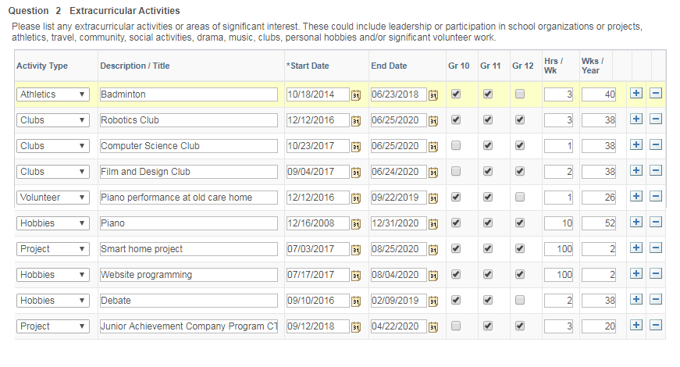

## Question 3 Extracurricular Activities - additional information (optional)

Provide any additional information about anything in the above table. (600 character limit)

Robotics club taught me how to lead a team efficiently and the importance of a timeline.

After participating in Hackathons, I initiated an innovation in computer science club for project-based learning, making learning more fun.

Founding Film and Design club taught me the importance of taking action, as I was able to create a community of people with similar interests, and provided a platform for communication.

I dedicate 2 weeks every summer to creating a smart home product and coding website every summer.

JA taught me the importance of listening to criticism from other people to improve.

Char count: 592

## Question 4 Additional Information

In addition to the specific information requested in all of the AIF questions, please tell us anything else about yourself that you would like us to know when we review your application. Please make sure to complete all sections of the AIF before submitting this page (900 character limit)

# Engineering

## Question 1 Engineering Interests and Goals (*Required)

Briefly explain why you are interested in engineering and particularly in the program to which you have applied. Comment, for example, on your interests and abilities your career goals, exposure to engineering through school-related and other experiences, and discussion you have had with engineers, teachers, current or past Waterloo Students. (900 character limit)

Both my grandfathers and my father are engineers, and have taught me how to think like an engineer. Playing with LEGO and learning how to code MCUs developed my skills as a mechanic and a programmer. My interests led me to the robotics club, and I was fascinated by the tools available and the extended functionality and application of robots.

I talked to mechanical engineers during SHAD, which I learned the interactive nature of software and hardware. This inspires me to take the mechatronics degree at Waterloo, as it is a blend of Canada’s best computer science and mechanical engineering courses. During Hack The North, Engineering students from Waterloo often praise the freedom in clubs and innovative atmosphere in the school. This atmosphere will help me sustain my interest in the field of technology, and help me achieve my goals as an engineer.

Word Count 861

## Question 2 More About Your Goals (*Required)

What sorts of things would you like to do or accomplish in Waterloo Engineering and why?

My grandparents love telling stories of what life was like before computers existed, and how they make our life much more comfortable. Technology indeed solves many problems, and I have always tried to use technology to make my family’s life easier. I dedicate a week every summer on my “smart home project”, which I try to create something to improve life in my family. I tried to make a wireless charging desktop the first year and a face unlocked smart door lock the second. Neither of my attempts have succeeded because I lacked the necessary knowledge such as a deep understanding of tesla coil properties and robust facial recognization algorithms. The Mechatronics Engineering program helps me build my foundation, as it will provide me the necessary knowledge to innovate. I look forward to meeting like-minded people, with whom I can cooperate to make the world a better place.

科技宅拯救世界

Word Count: 898

## Question 3 Programming Knowledge

If you have applied to Software Engineer you are required to demonstrate that you have experience in developing well-structured, modular programs. However, all applicants should list their programming experiences if applicable.

For every programming language in which you have at least four months of programming experience, list the language, number of months experience you have in using the language (not how long you have known it), and capacity in which you use the language (e.g. courses completed, work experience, self education). (600 character limit)

I have over 36 months of experience with c++. In the first 6 months I learned how to control a robot with basic code. I then started to incorporate APIs and internet access on the robot. I have been preparing for the CCC last 4 months by learning advanced concepts such as dynamic programming.

My knowledge in HTML, CSS and javascript grew together. I first learned them by myself during the summer, to code a website for the robotics club. I continued making websites and now have experience coding websites for startups. I now teach other people web design voluntarily as a form of giving back.

Word Count: 595